Software requirements specifications for car pooling system

A SarSubz LUMS Initiative

**Software Requirements Specifications**

**for**

**Car Pooling System**

**Prepared by,**

**Group-V**

**Hasan Abbas(2014-10-0059)  
Muhammad Wajahat (2014-10-0128)  
Luqman Ghani (2014-10-0180)  
Usman Zaheer (2014-10-0222)**

**February 28th 2013**

**Table of Contents Content Page**

1. **Introduction 3**
2. **Project Description 3**

**2.1 Product Prespective 3**

**2.2 Product Functions 3**

**2.3 User Characteristics 4**

**2.4 Usecase Diagram 5**

**2.5 Context Diagram 6**

**2.7 Design and Implementation Constraints 6**

**3. Specific Requirements 7**

**3.1 Functional Requirements 7**

**3.3 Attributes 11**

**Appendix A: Survey 12**

**Appendix B: Open Question asked online 14**

**1. Introduction**

* 1. **Purpose**

This SRS describes the software functional and non-functional requirements for release 1.0 of the Car Pooling System (CPS). This document is intended for use by the project team to implement and verify the correct functioning of the system. Unless otherwise deemed necessary, all requirements specified in this document are high priority and are committed for release 1.0.

* 1. **Project Scope and Product Features**

The Car Pooling System will permit the students and employees of Lahore University of Management Sciences (LUMS) to plan road trips to or from LUMS at the mutual discretion of the car owner and the participating members of the trip. The features of this system are further discussed in Section III – System Features.

**2. Overall Description**

**2.1 Product Perspective**

This system will not be working independently. It will be designed on PHP with Oracle and is intended to work on the servers at LUMS, ingraining it with the rest of the intra-network that is accessible to every member of the LUMS community.

**2.2 Product Functions**

The website shall provide a user login feature that will enable every member of the LUMS community (student, faculty or staff) to login with their LUMS id and password to enter the system. This will be done in accordance with the Information Services Technology (IST) office in LUMS which oversees the internet facilities and security of the users in LUMS.   
  
Moreover, inside the system, there will be a feature to “plan a trip” and “search for a trip”. The latest planned trips can also be displayed at this home page of the user for them to have a look at the latest trips being planned, a feature to aid searching for relevant trips even more.  
  
The “Plan a Trip” and “Search for a Trip” features would each lead to separate forms with their own respective functions which will used to be utilized to maximize information gathering.  
  
Another functionality added would enable an interested user to join a trip plan. Also, if the trip limit is exceeded i.e. there are more people applying for a trip than there is space in the vehicle of the lift provider, then a wait list should get generated to accommodate the immediate interested users.

Furthermore, another functionality that is deemed important is the type of trip being generated i.e. whether a user wants a trip that is gender specific or they have no such preferences.

Also, as these trips are not restricted to Lahore and users can venture into out of city trips as well, it is important that a function of confirming trips is also put in practice which will confirm the trips a day or so before the actual trip so all members of the trip can cement their presence.

**2.3 User Characteristics**  
  
There are several users of the Car Pooling system,

* The trip planner who initiates the trip and is a car owner, therefore labelled as the “Lift Provider”.
* The trip planner who initiates the trip but does not own a car and is labelled as the “Trip Member (Initiator)”.
* A user who selects one of the trips to join in but does not own a car, also labelled as a “Trip Member”.
* A user who selects one of the trips to join, owns a car and proposes to be the lift provider thus labelled as the “Lift Provider” as well.

The above mentioned are only the users who would be using the system, however, it is important to highlight the presence of a “Maintenance Officer” who would be overseeing the maintenance of the system and making sure that all functions of the system continue to work efficiently and handle any reported queries or system breakdowns.

**2.4 Use Case Diagram**

**Lift Provider or**

**Applicant**

**Figure 1. Use Case diagram for the SarSabz Carpooling System**

**2.5 Context Diagram**

Maintenance of the System

Return all the results of query

Send a user generated query

Send ranked results for the query

Post a lift offer

Search / Apply for lift

**User**

**(Lift Provider/ Applicant)**

**Admin**

**Database Management System**

**(Lifts Offered/ Required)**

**2.6 Design and Implementation Constraints**

1. System developed with technologies compatible with PHP.
2. The system shall use the current corporate standard Oracle database engine.
3. All HTML code shall conform to the HTML 4.0 standard.

**3. Specific Requirements**

**3.1 Functional Requirements**

The functional requirements are the requirements which the system should satisfy. They are defined and discussed in the following method,

**Description**: A description of the specific requirement  
**Input**: A description of what the software system will be getting from the user.  
**Processing**: A description of what the software system be doing with the input  
**Output**: A description of the resulting state/new state of the system.

The input, processing and output sections are mentioned only on a need basis.

**3.1.1 General Requirements**

**Functional Requirement 1:**

* **Description:** Apply for a lift
* **Input:** Choose whether user owns a car or not
* **Processing:** Database updated about current user.
* **Output:** Upload form with the necessary information regarding the trip preferences in either case.

**Functional Requirement 2:**

* **Description: S**earch for a lift in the system
* **Input:** Enter search preferences – destination/date/time of departure/time of arrival/other info
* **Processing:** Information stored in database of system with users login and note time of entry.
* **Output:** Update users entry and display on systems website for public view.

**Functional Requirement 3**

* **Description:** Ranked search of lift providers based on feedback
* **Input:** Display list of lift providers with their ranks
* **Processing:** Return information from system database about highest ranked lift providers with feedback
* **Output:** Page updated with lift provider ratings and accompanying feedback

**Functional Requirement 4**

* **Description:** Scope is limited to LUMS students, faculty and staff only
* **Input:** User logins with LUMS id and password
* **Processing:** Checking id and password if they match with list of logins and passwords obtained from IST to ensure user is a member of the LUMS community
* **Output:** Let user enter website if information valid otherwise upload deny entry webpage.

**Functional Requirement 5**

* **Description:** LUMS must be either a source or a destination
* **Input:** Option to choose LUMS either in source or destination in form.
* **Processing:** Check whether LUMS has been chosen as one the destinations
* **Output:** If LUMS has been chosen, save form, otherwise display error to choose LUMS as either source or destination.

**Functional Requirement 6**

* **Description:** The destination or source must not be constrained to Lahore only but any city can be entered for a trip
* **Input:** Form entry location
* **Processing:** Accept location if valid i.e. no numbers or invalid digits written with alphabets.
* **Output:** Display location entered by user.

**Functional Requirement 7**

* **Description:** Waiting list for lift applicants generated if trip limit exceeds to accommodate other interested users in the same trip in case someone cancels trip.
* **Input:** User submits entry to register for a particular trip
* **Processing:** System checks whether the trip limit is exceeded or not. If exceeded, then save the entry as “waitlisted” and assign a number, depending on the number of
* **Output:** Notify user if they have been registered for trip or if waitlisted, notify with wait list number and notify that trip limit is exceeded.

**Functional Requirement 8**

* **Description:** Search results will be ranked on user preference matching
* **Input:** User enters preferences eg. School, major, gender, group specification (student, faculty or staff), vehicle type, source, destination, time of departure and arrival, any costs negotiated for trip and any relevant details to aid the search.
* **Processing:** System shall search database and display results ranked on cosine similarity or any other matching algorithm.
* **Output:** Display ranked results and search type (number of results found in how much time) to the user.

**Functional Requirement 9**

* **Description:** System should address cancellation of a lift from either the lift provider or life taker.
* **Input:** User selects option to cancel their participation in a trip.
* **Processing:** Takes input and deletes user from a trip and rotates wait list to notify the next immediate trip participant.
* **Output:** User gets notification they have been removed from the trip list.

**Functional Requirement 10**

* **Description:** System should have a feature enforcing re-confirmation from both parties.
* **Input: N/A**
* **Processing:** System should notify all participants (via email or sms) that their planned trip is due in a day and they should reconfirm their participation. System keeps a note of when a trip is due to be executed and on cue generates a reconfirmation message a day before.
* **Output: N/A**

**Functional Requirement 11**

* **Description:** The system should not allow to apply for conflicting trip by the same user.
* **Input:** User registers for a trip OR signs up for an existing trip
* **Processing:** The System would check if the user is registered in any other trips and if yes, then check their time of commencement. It the times clash, then return error in saving, otherwise save the trip update in the user’s database section.
* **Output:** If times clash, display error message, otherwise, trip saved and display save success message to the user.

**Functional Requirement 12**

* **Description:** The system should ask for the gender preferences when a trip is being planned. Some users might want a male or female only trip but some may not have any preference.
* **Input:** User selects gender preference – “male only”, “female only” , “no gender preference”
* **Processing:** System stores the user preference and marks it as a “priority requirement” to be fulfilled when other users select to register for this trip.

**Functional Requirement 13**

* **Description:** The system should handle the possibility of regular (weekly/monthly etc) trips along with one-time trips.
* **Input:** User selects option what sort of trip they are going to advertise for.
* **Processing:** System saves user preference and lets them continue with the form

**Functional Requirement 14**

* **Description:** The system asks for preferred group of partners i.e. students, faculty or staff for each trip
* **Input:** User selects option about trip preference.
* **Processing:** System saves user preferences and marks it as “priority requirement” that needs to be fulfilled by every consequent user registering for that trip.

**3.3 Attributes**

**3.2.1 Availability**

The system would be active 24 hours a day. It will not be unavailable at any time other than a scheduled maintenance which would be advertised well in time.

**3.2.2 Security**

Security checks at login and basic system correctness checks during trip planning and searches to maintain a high level of efficiency and avoid overloading the system.

**3.2.3 Maintainability**

Scheduled maintenance will be carried out to maintain the system server and database. It will be easy to integrate the system.

**APPENDIX A: Survey**

A survey was carried before the commencement of this SRS to gather information about the project and develop a deeper understanding of the needs and expectations of the LUMS community regarding the project and what we can integrate further into this project.   
  
This was a two day survey and eighty-eight (88) replies were recorded.  
  
Our survey results are displayed as follows,

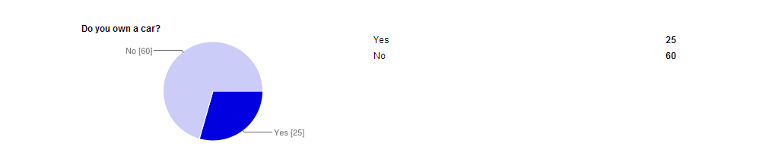

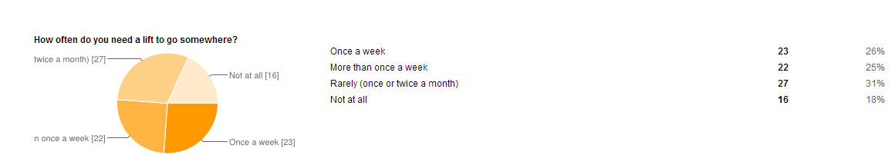

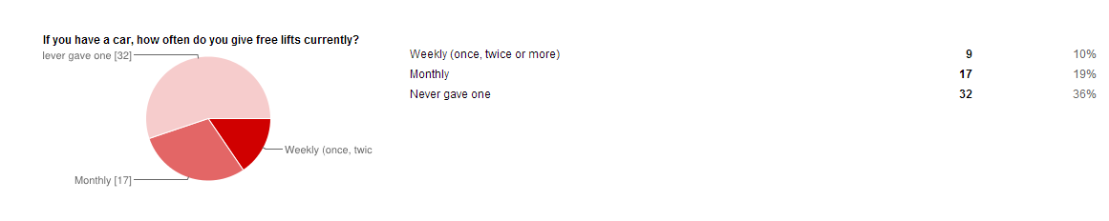

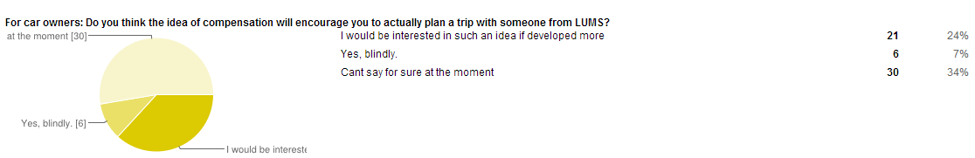

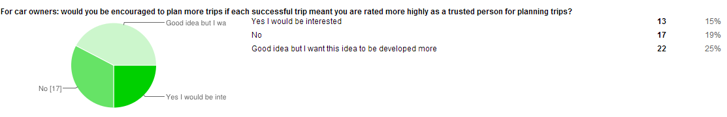

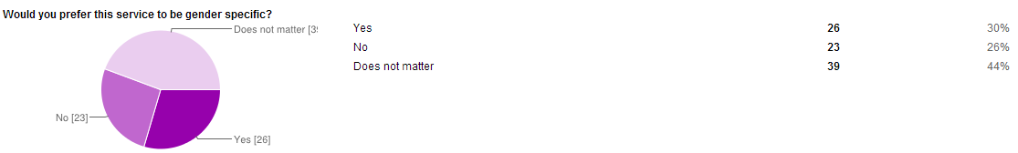

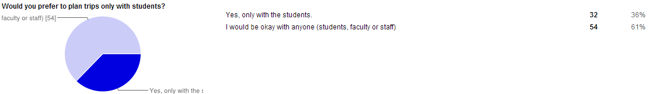

**APPENDIX B: Open Question asked online**

**Do you think the car owners should get compensated by sharing the cost for a trip?***/* This was a descriptive answer. Only the most relevant answers are discussed here */*

* Yes he should. All the people in the car should share cost of the fuel.
* divide the cost of gasoline etc. + give a very small fee to the car owner
* The car owner could be compensated by being paid the petrol/gas amount worth the meters driven. In addition, he could be paid a compensation set at a standard amount. For instance, his compensation could be15% of the total fuel cost incurred to him so essentially he would be receiving his fuel costs + 15% profit on them.
* Why do you need compensation? If you're dropping somebody whose house lies in your way, you don't need compensation.
* The driver should definitely ask for everyone to split the fuel costs.
* Yes, costs should be shared. They can fill the car with petrol/gas before the start of the trip and then charge then calculate how much of the fuel has been used during the trip, and divide the cost between everyone in the car.
* Yes a small fee for the many passengers.
* Yes there should be compensation why should one person be burdened. (Unless they are very rich and insist on paying)
* Compensation not a good idea per se, lifts can serve a nice little way of getting to know more of your campus fellows.
* Just divide equally among the people in the car depending on the fuel cost. But then there should be more than 3 people
* Owner's fee can be ignored if travelling with friends, but would expect to share fuel cost.
* Normally car owners offer a ride out of the goodness of their hearts, but yeah if they're going to go out of their way to drop you somewhere or want to turn giving lifts into a business, then asking for compensation makes sense.
* Yes its okay if the car owner asks for a little money as per his discretion but obviously much lower than rickshaw fares for the same ride.